| Software design |
| --- |
| Kahoot system |
| Version 1.0 |
| Prepared by class SE1617, Group 2  Ha Khanh Nam  Le Hong Chung  Vo Tien Tai  Nguyen Duc Manh  July 13, 2022 |

# **1.** **Document description**

This document describes solution version 1.0 for Kahoot System. It is divided into the following sections:

· In section 2 an overview of the Kahoot system’s requirements will be provided, including a list of system users, use cases, use case diagram, and activity diagrams that describe the most important use case scenarios.

· In section 3 an E-R diagram and all tables of the Kahoot system in detail will be presented.

· In section 4 all classes organized in the layers and their behaviors (sequence diagrams) for the most important use cases will be presented.

· In section 5 the most screen prototypes will be presented.

# **2.** **SRS overview**

## ***2.1. List of system users***

1. Student: The person can do the quiz created by teacher

2. Teacher: The person can manage quiz for student do the quiz

## ***2.2. List of use cases***

1. *Login*

2. *Register*

3. *Search quiz*

4. *Do quiz*

5. *View result*

6. *View all result*

7. *Manage quiz*

## ***2.3. Use case diagram***

### **2.3.1. Preliminary use case diagram**

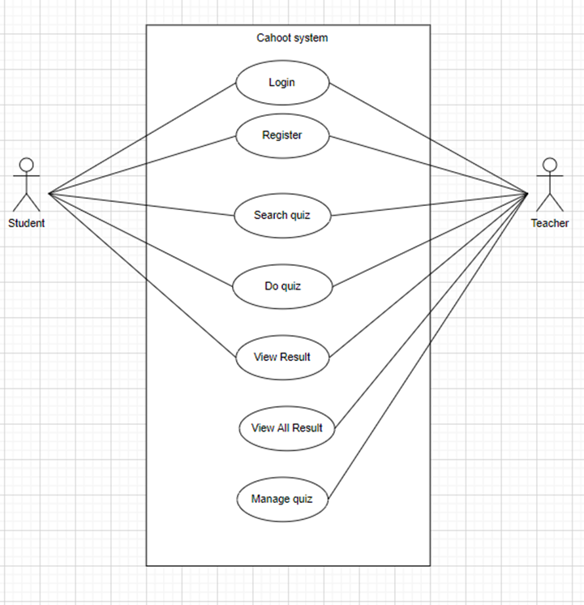

### 

### **2.3.2. Use case detail diagrams**

#### **2.3.2.1. Use case “Search quiz”**

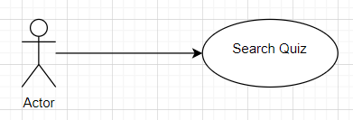

#### **2.3.2.2. Use case “Do Quiz”**

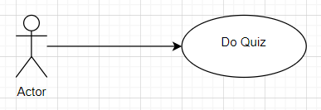

#### **2.3.2.3. Use case “View Result”**

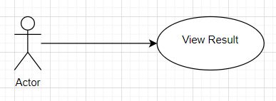

#### **2.3.2.4. Use case “View All Result”**

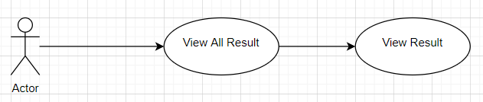

#### **2.3.2.5. Use case Manage Quiz”**

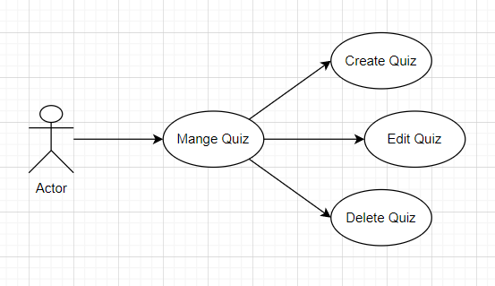

## ***2.4. Activity diagrams of use case scenarios***

### **2.4.1. Activity diagram for use case “Login”**

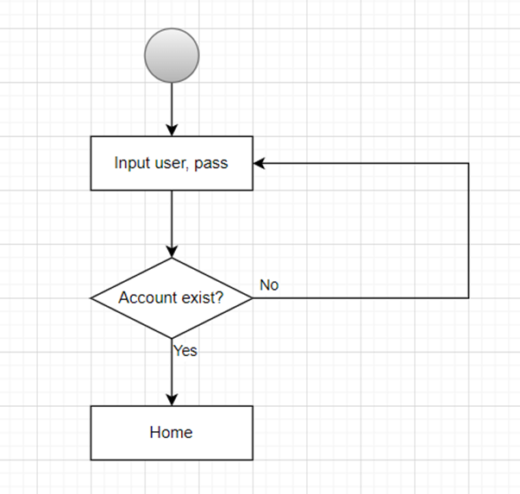

### **2.4.2. Activity diagram for use case “Register”**

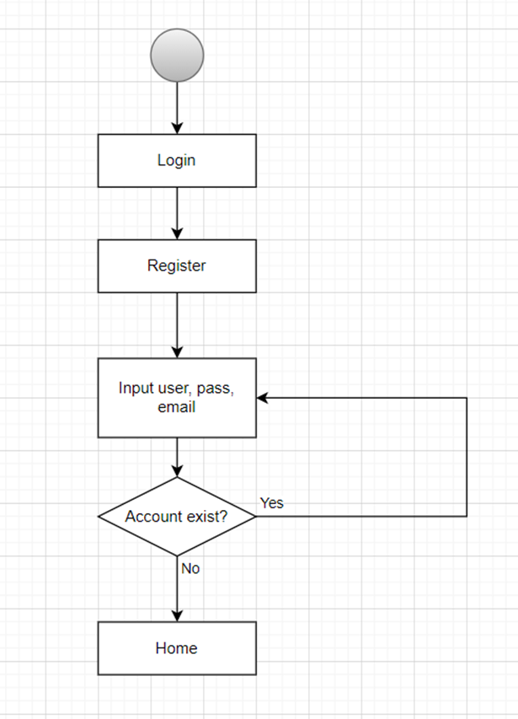

### **2.4.3. Activity diagram for use case “Search Quiz”**

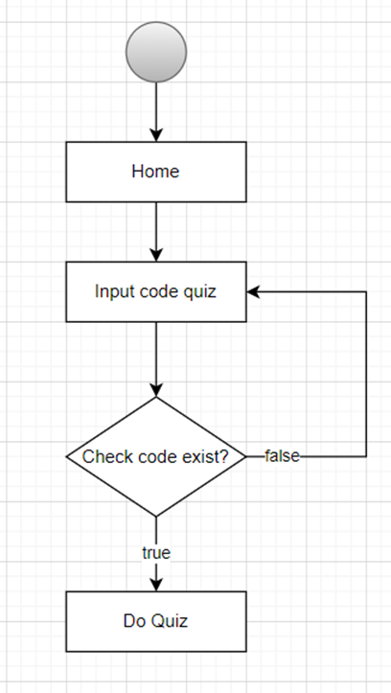

### **2.4.4. Activity diagram for use case “Do Quiz”**

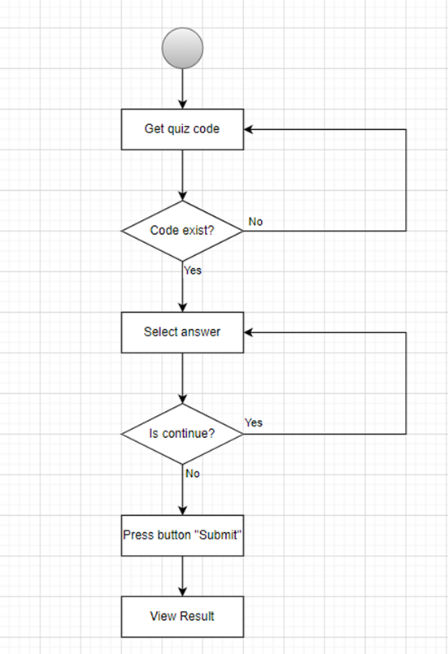

**2.4.5. Activity diagram for use case “View Result”**

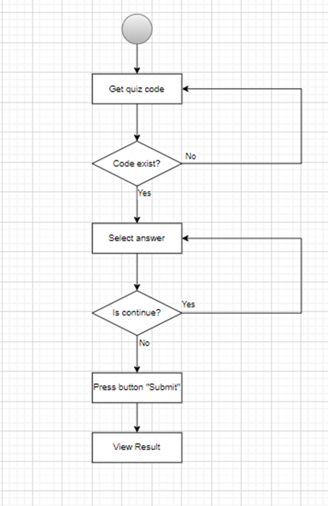

### **2.4.6. Activity diagram for use case “View all result”**

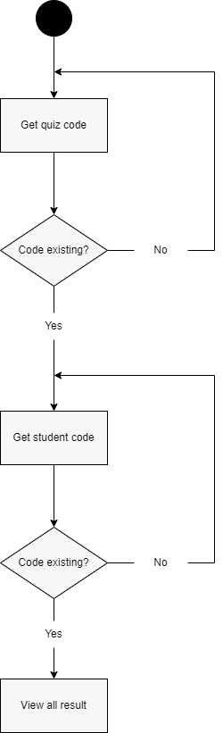

### **2.4.7. Activity diagram for use case “Manage Quiz”**

# **3.** **Data model**

## **3.1.** **Entity Relationship Diagram**

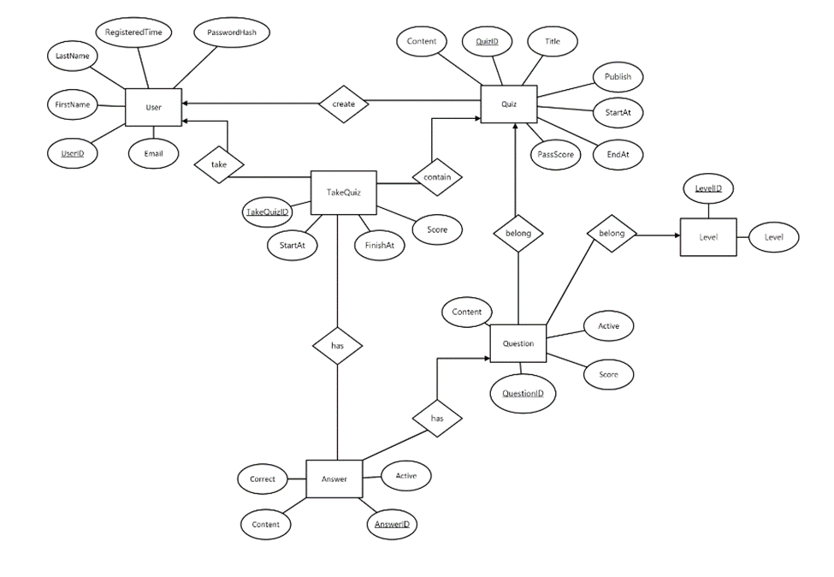

## 

## **3.2.** **Table details**

**3.2.1.** **Table name: User**

| **Field Name** | **Type** | **Size** | **Note** |
| --- | --- | --- | --- |
| UserID | Integer |  | Primary key |
| PasswordHash | String | 250 | Not null |
| Email | String | 250 | Unique, Not null |
| FirstName | String | 100 | Not null |
| LastName | String | 100 |  |
| RegisteredTime | Datetime |  | Not null |

**3.2.2.** **Table name: Quiz**

| **Field Name** | **Type** | **Size** | **Note** |
| --- | --- | --- | --- |
| QuizID | Integer |  | Primary key |
| Title | String | 250 | Not null |
| Content | String | 250 |  |
| Pulish | Bit |  | Not null |
| StartAt | Datetime |  | Not null |
| EndAt | Datetime |  | Not null |
| PassScore | int |  | Not null |
| UserID | Integer |  | Foreign key |

**3.2.3.** **Table name: Level**

| **Field Name** | **Type** | **Size** | **Note** |
| --- | --- | --- | --- |
| LevelID | Integer |  | Primary key |
| Level | String |  | Not null |

**3.2.4.** **Table name: Question**

| **Field Name** | **Type** | **Size** | **Note** |
| --- | --- | --- | --- |
| QuestionID | Integer |  | Primary key |
| Content | String | 250 | Not null |
| Active | Bit |  | Not null |
| Score | Integer |  | Not null |
| QuizID | Integer |  | Foreign key |
| LevelID | Integer |  | Foreign key |

**3.2.5.** **Table name: Answer**

| **Field Name** | **Type** | **Size** | **Note** |
| --- | --- | --- | --- |
| AnswerID | Integer |  | Primary key |
| Content | String | 250 | Not null |
| Active | Bit |  | Not null |
| Correct | Bit |  | Not null |
| QuestionID | Integer |  | Foreign key |

**3.2.6.** **Table name: Take Quiz**

| **Field Name** | **Type** | **Size** | **Note** |
| --- | --- | --- | --- |
| TakeQuizID | Integer |  | Primary key |
| StartAt | DateTime |  | Not null |
| FinishAt | DateTime |  | Not null |
| Score | Integer |  | Not null |
| UserID | Integer |  | Foreign key |
| QuizID | Integer |  | Foreign key |

# **4.** **Class diagram**

## **4.1.** **List of classes in the Layers**

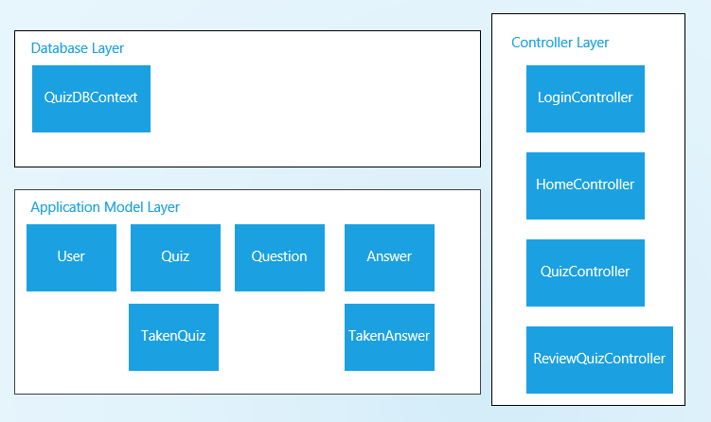

# **5.** **User Interface Model Design**

## **5.1.** **User interface model design**

* Register

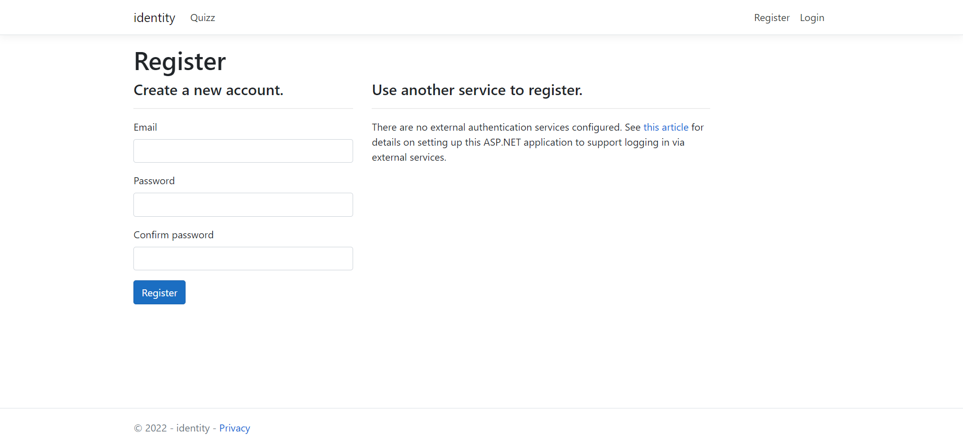

* Login

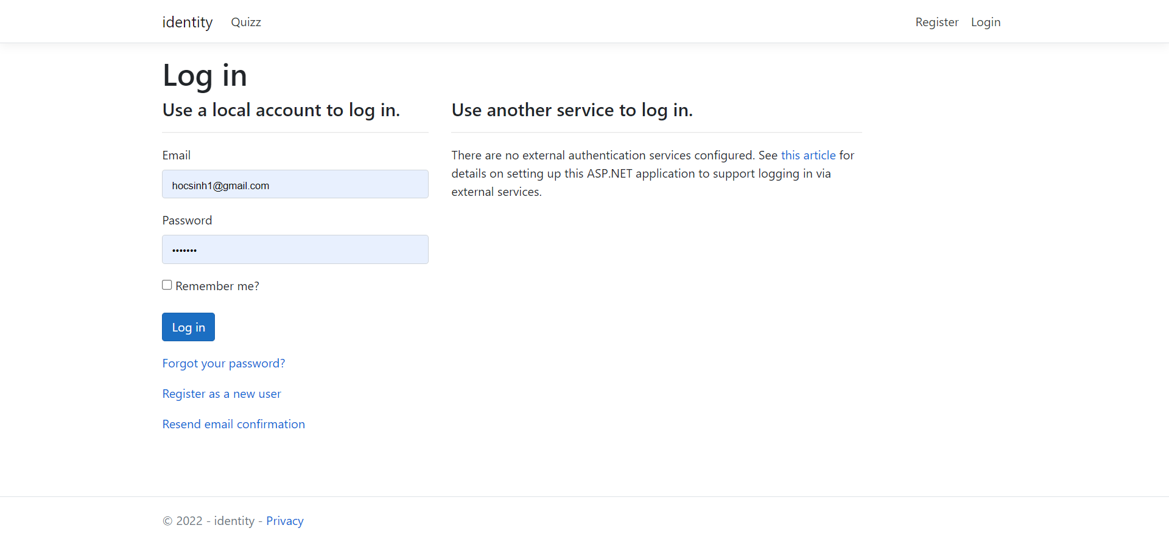

* Forgot Password

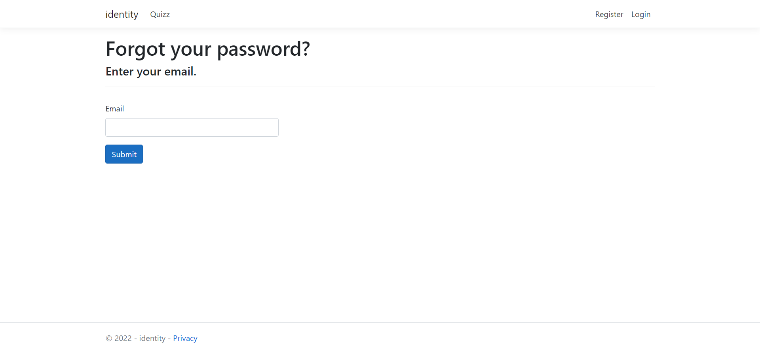

* Resend Email Confirmation

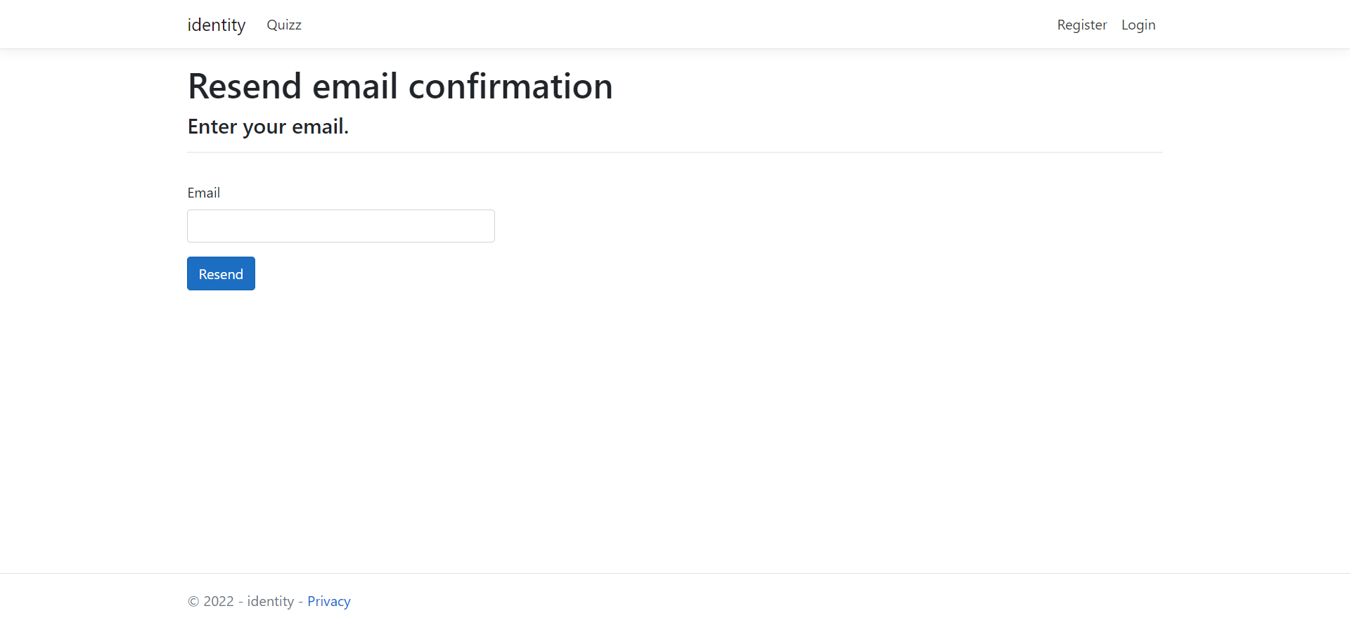

* Quiz List

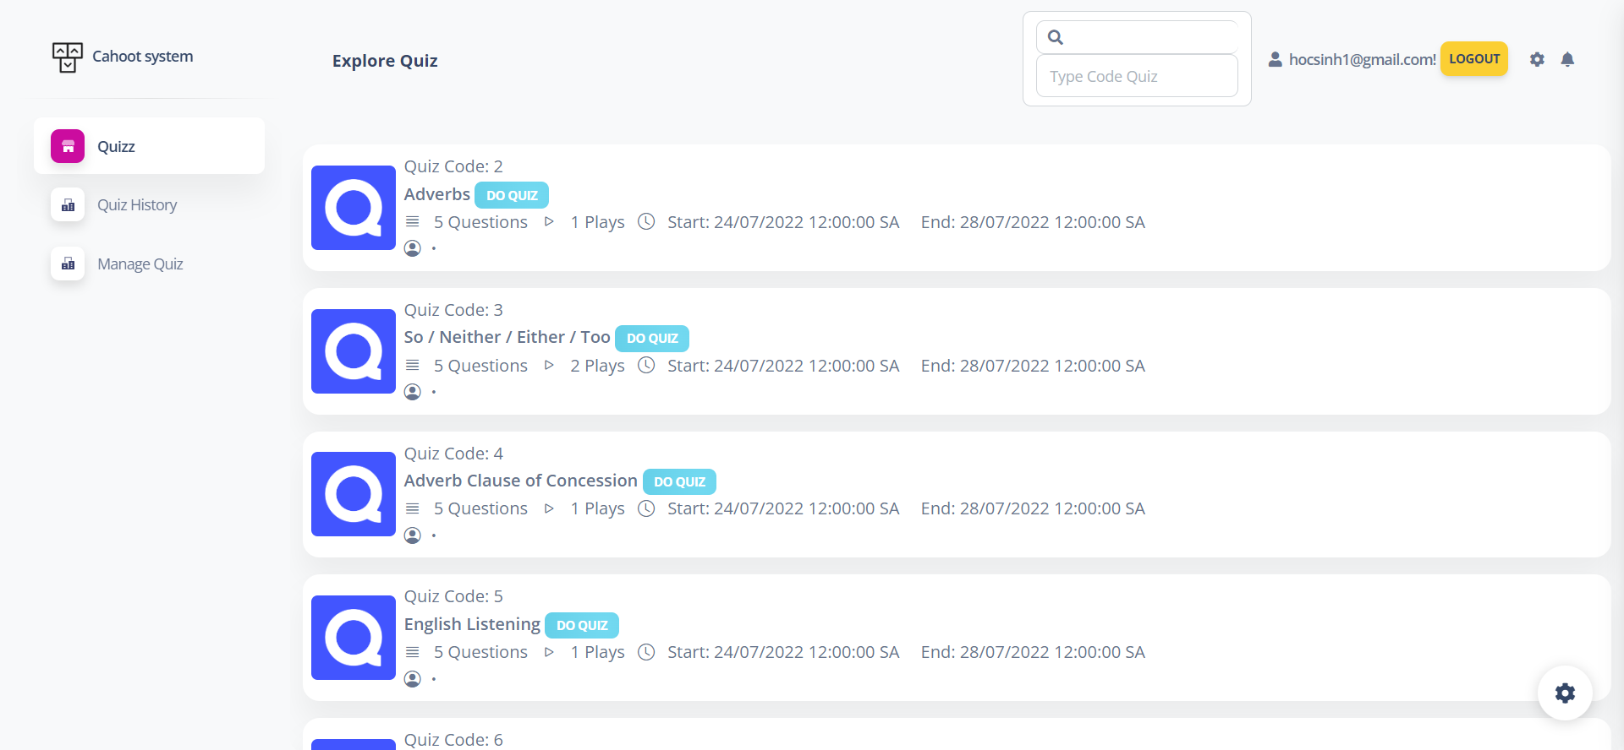

* Do Quiz

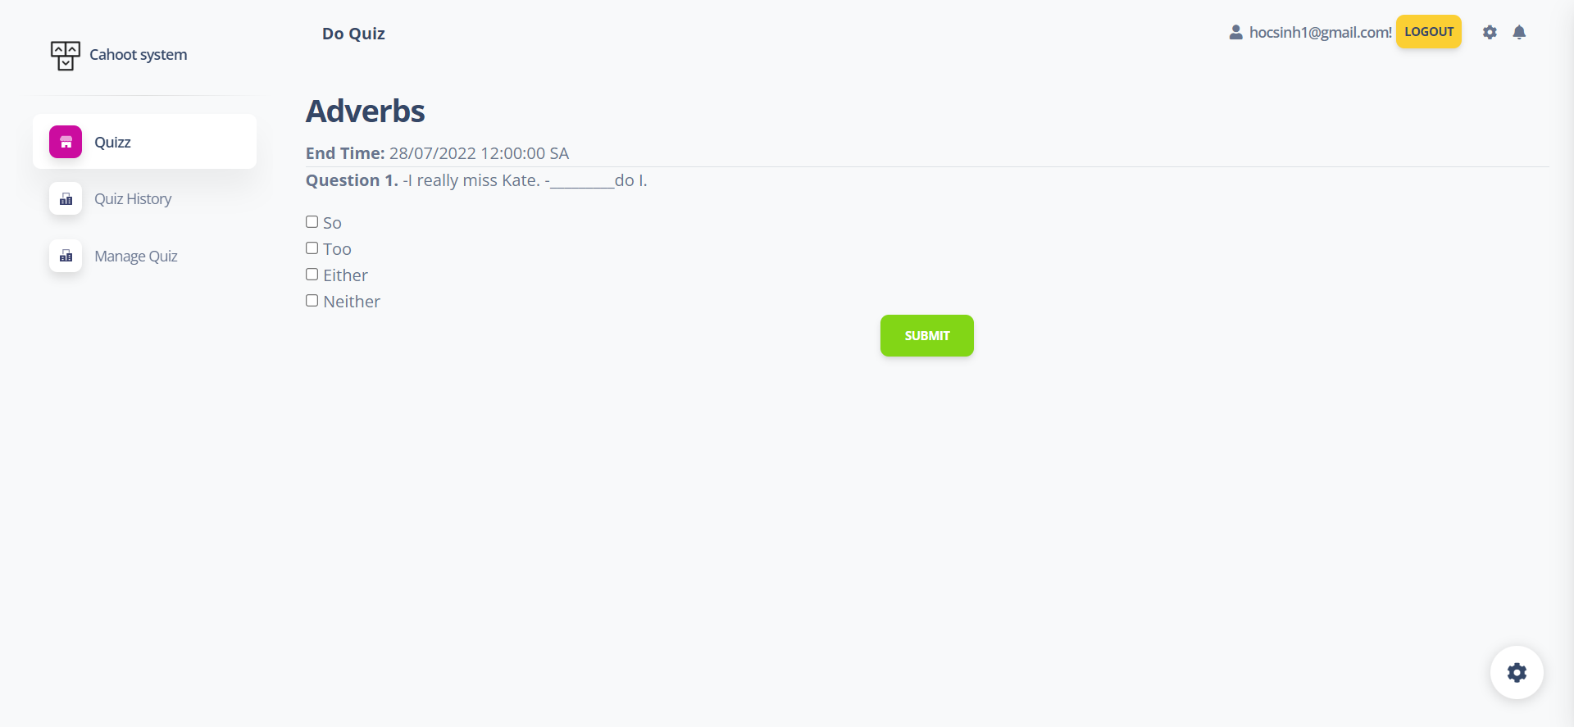

* Quiz Result

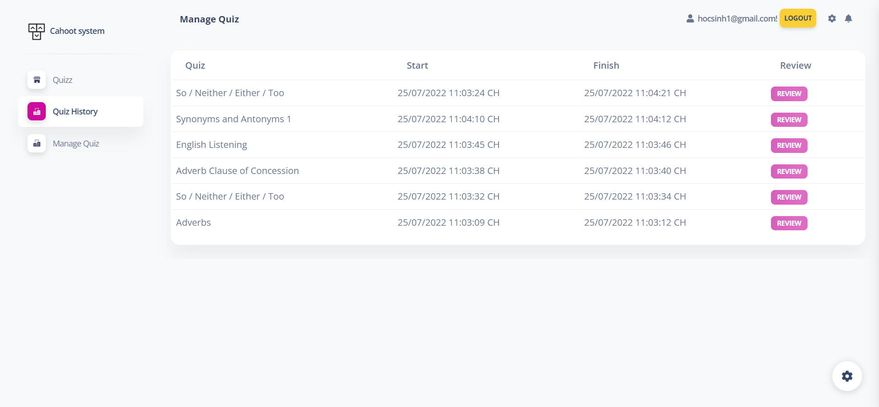

* Quiz Review

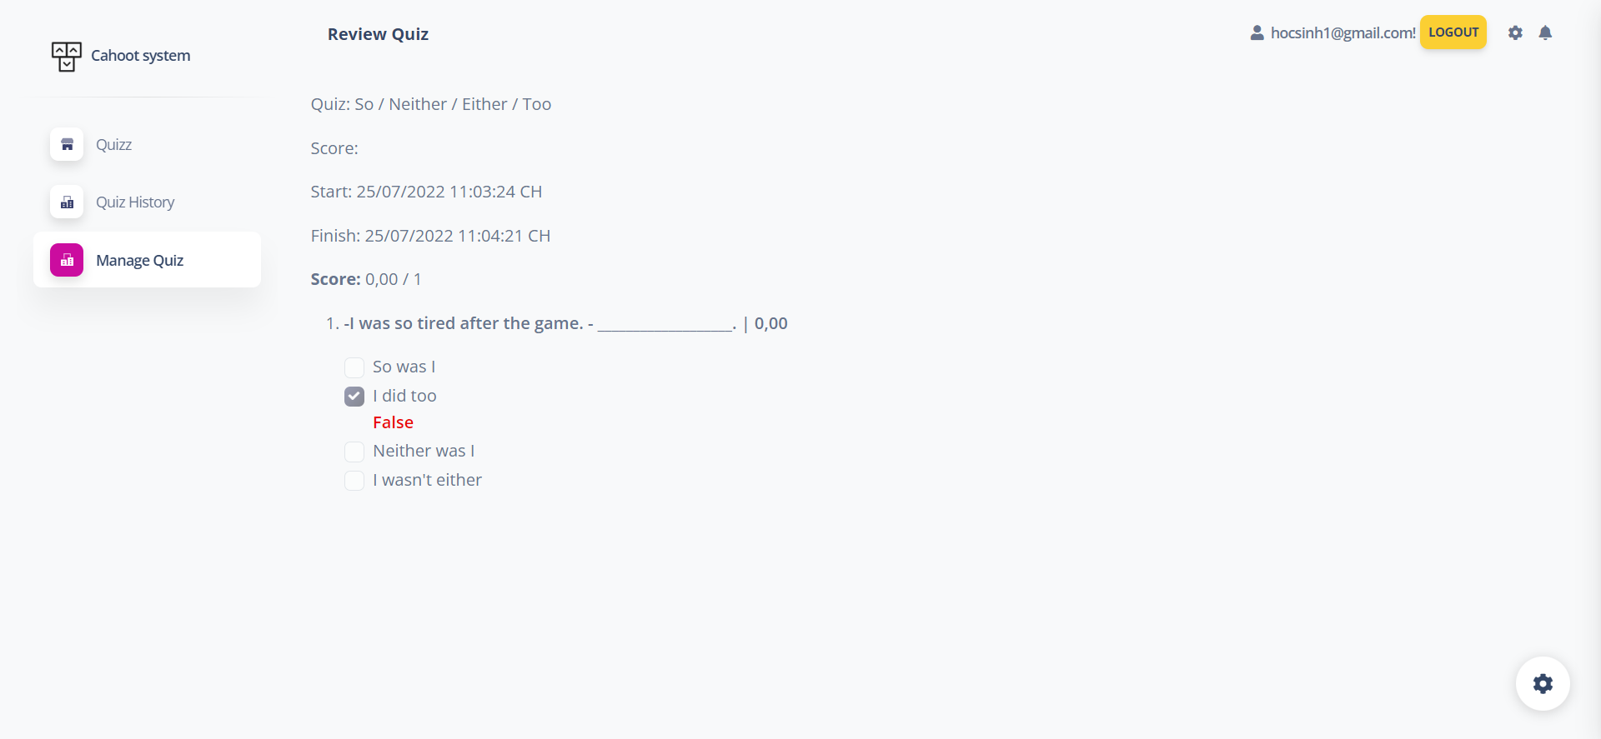

* Manage Quiz

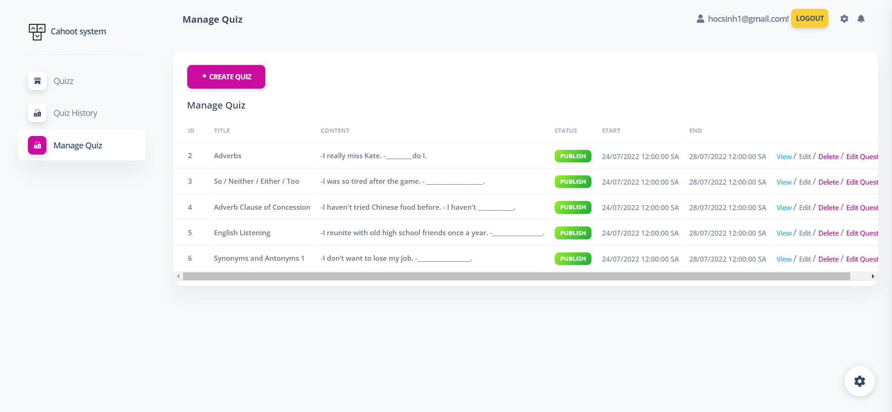

* Create Quiz

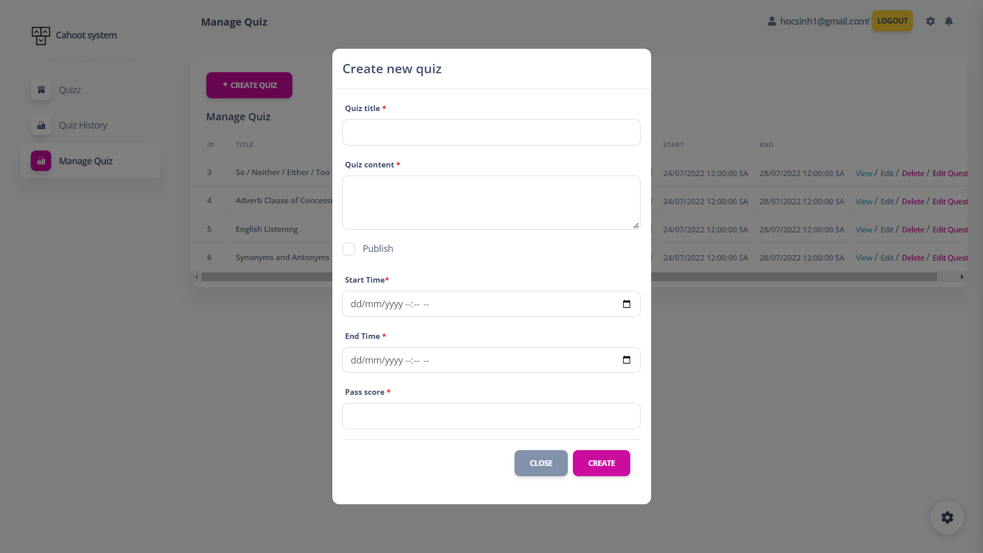

* View Quiz

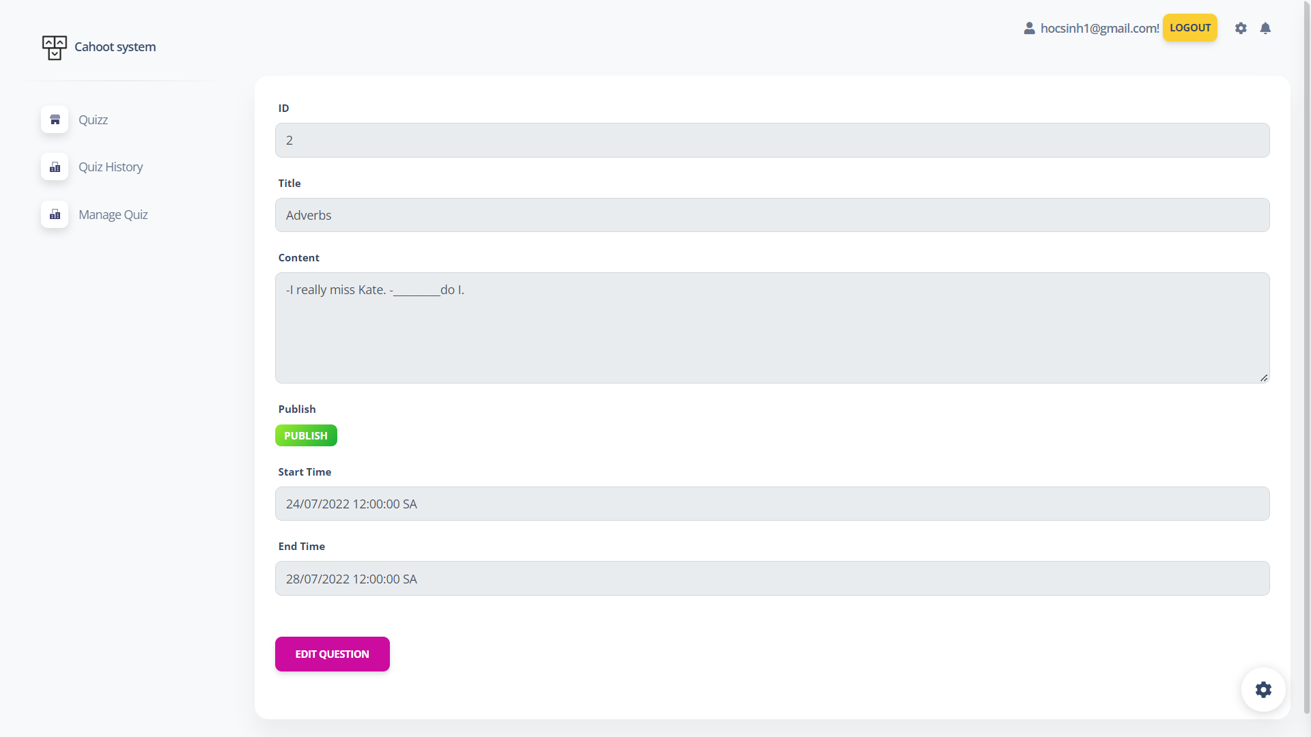

* Edit Question

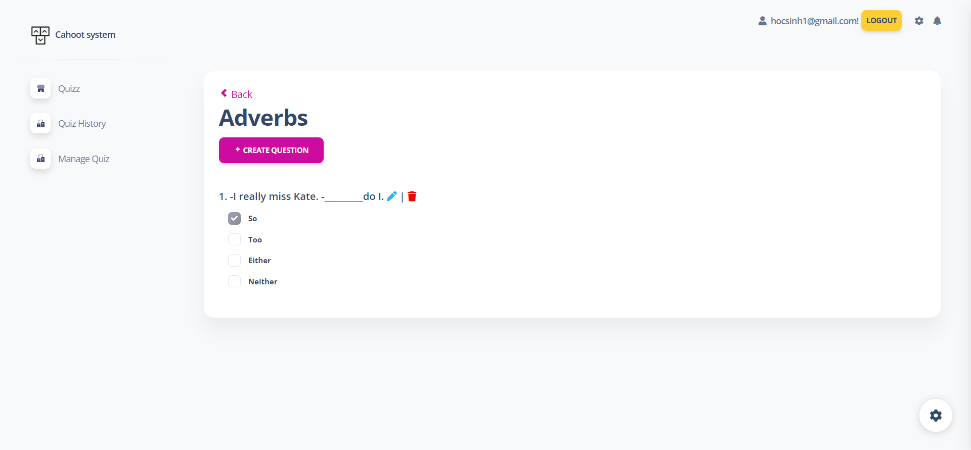

* Edit Quiz

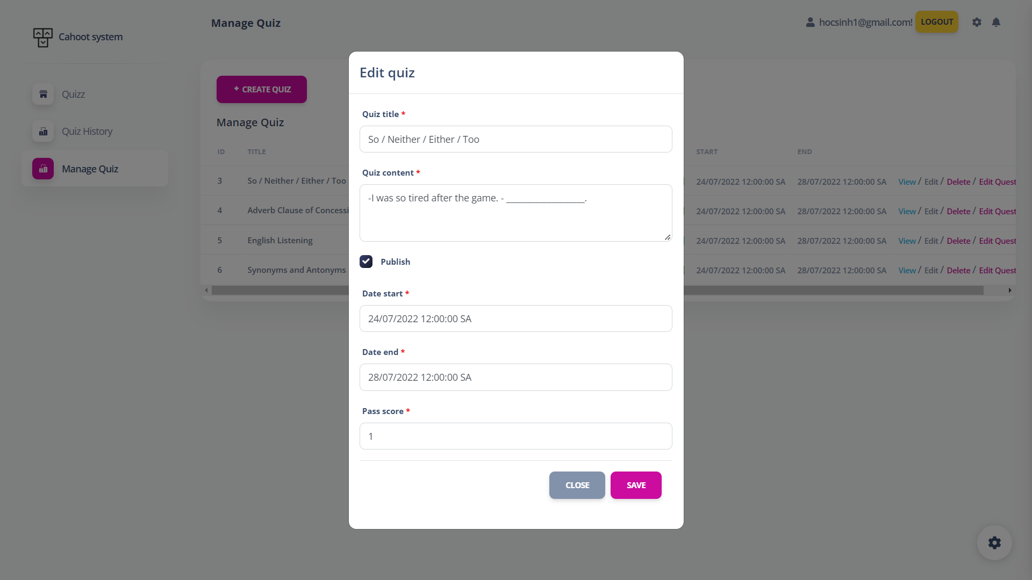

* Edit Profile

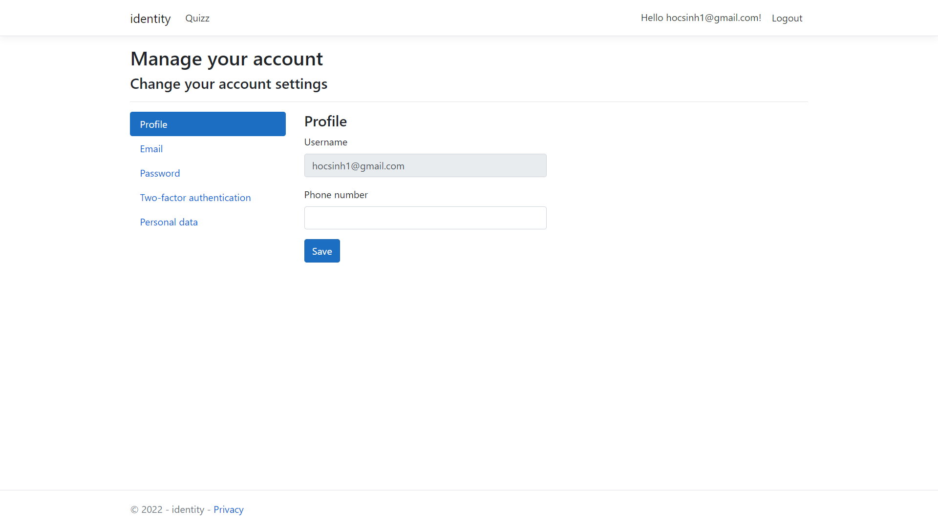

* Edit Email

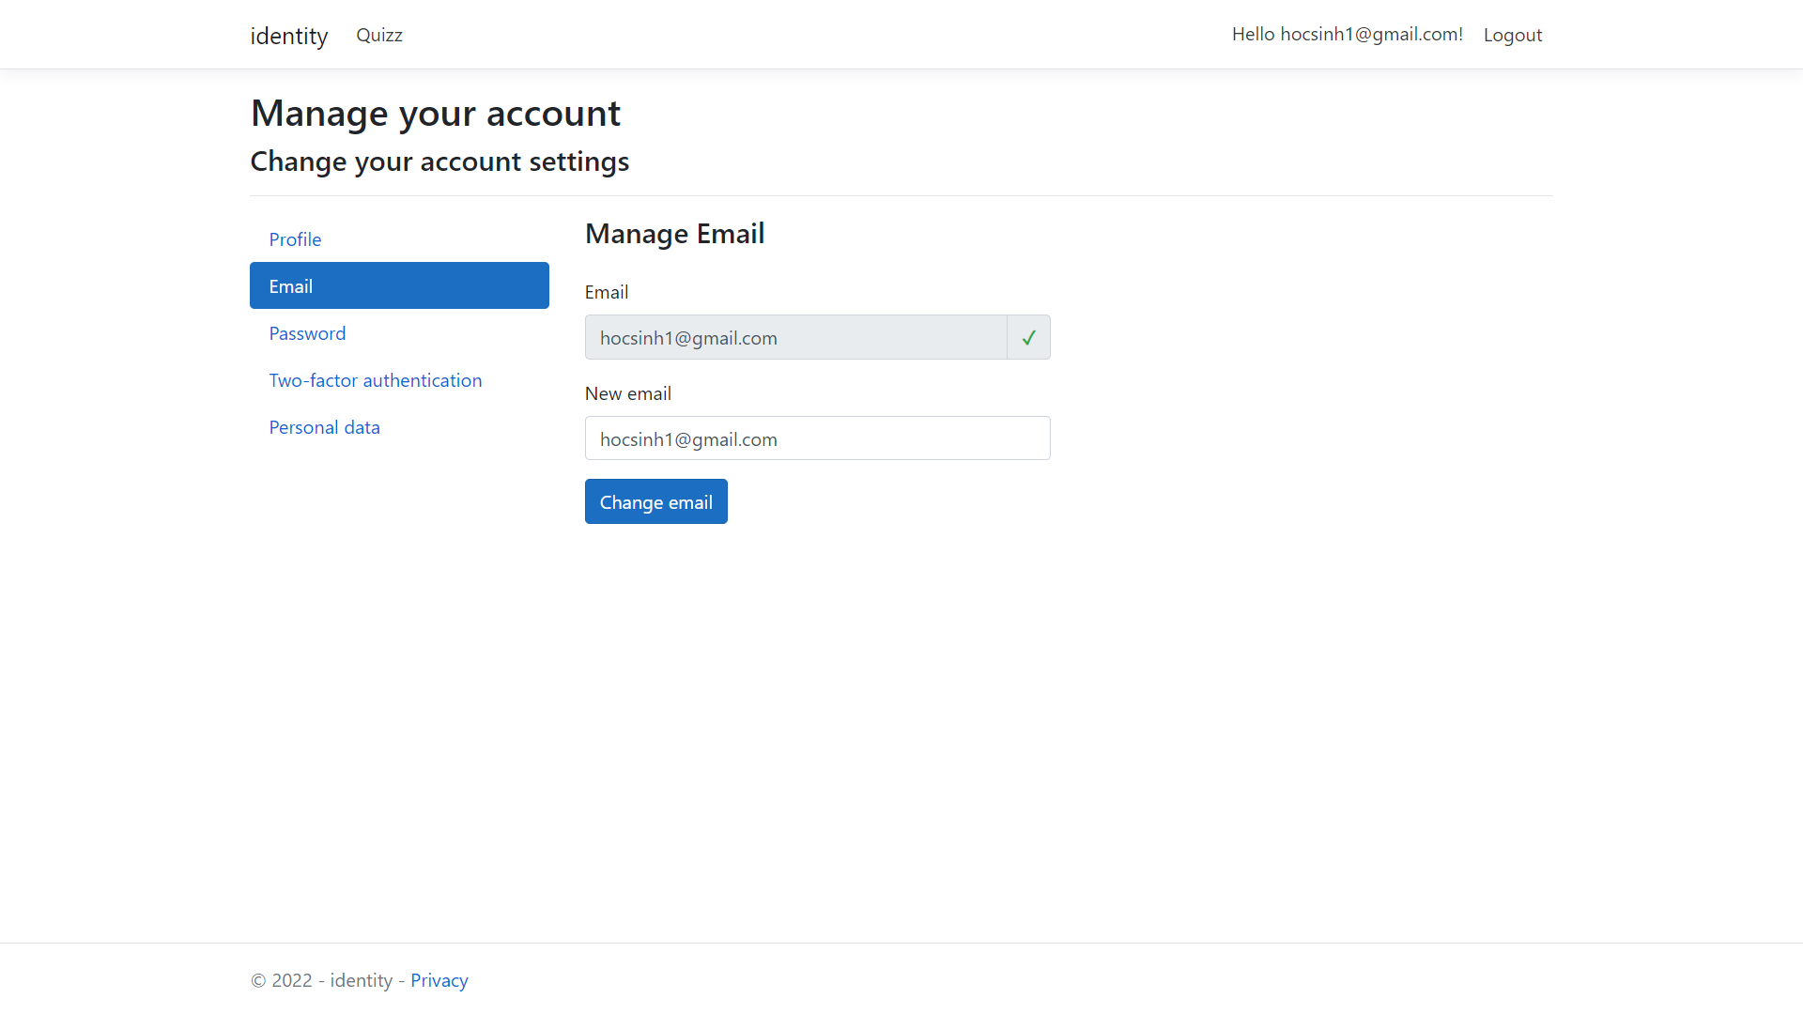

* Change Password

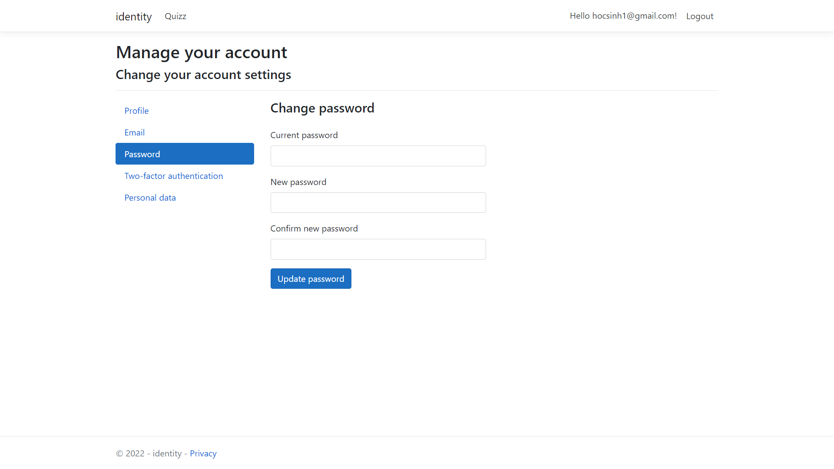

* Two-factor authentication

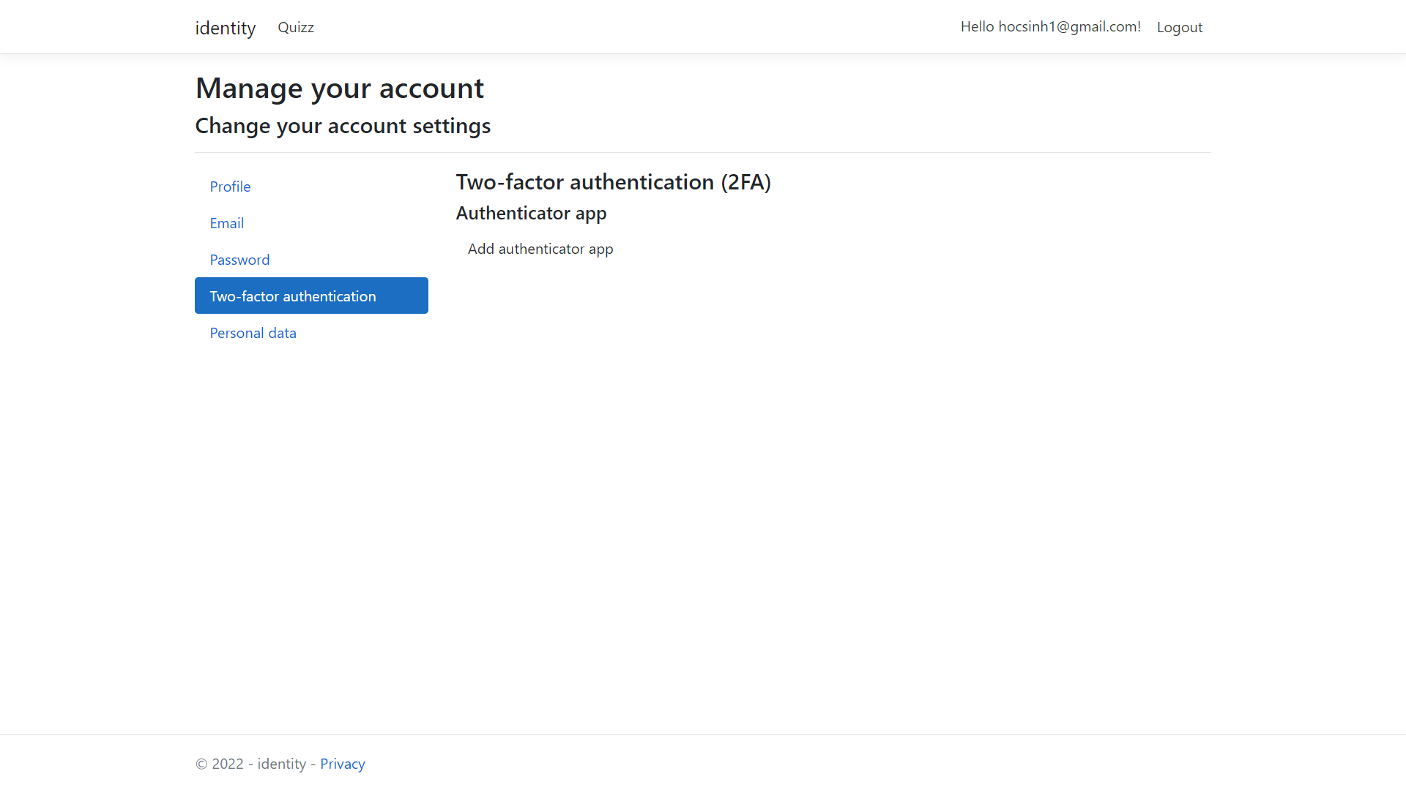

* Personal Data

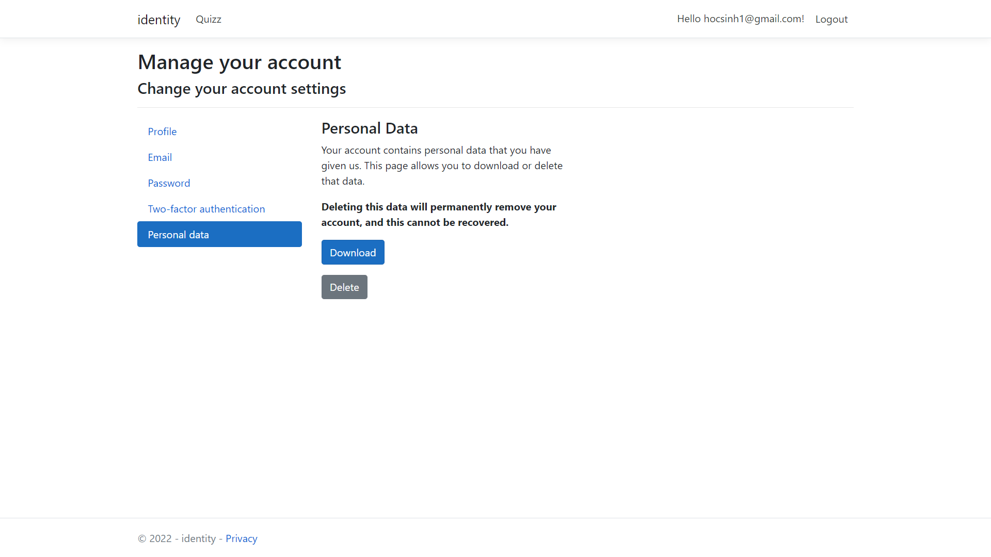

## **5.2.** **Interface Flow Diagrams (p. 51)**

